**D.K.T.E. Society’s Textile and Engineering Institute,**

**Ichalkaranji.**

(An Autonomous Institute, Affiliated to

Shivaji University, Kolhapur)

Accredited with ‘A+’ Grade by NAAC

Department of Computer Science & Engineering

2020-2021



INTERNSHIP REPORT ON

**FULL STACK WEB DEVELOPMENT**

**Under The Guidance Of**

Prof. S. R. Patil

INDEX

|  |  |
| --- | --- |
| **Content** | **Page Number** |
| 1. Certificate | 2. |
| 2. About Company | 3. |
| 3. Aim and Objective | 3. |
| 4. Working Methodology | 4. |
| 5. About Projects | 4. |
| 6. Problem Statement | 5. |
| 7. Solution | 5. |
| 8. Output Solution | 6. |
| 9. Template Snapshot | 8. |
| 10. Conclusion | 10. |
| 11. About My Role | 10. |

# INTERNSHIP REPORT

CST318

Abstract

This report is being presented as part of CST318 course to describe the details of the internship done as part of the winter internship process of the DKTE’s TEI Ichalkaranji, curriculum.

Priyanshu Ekal

PRN: 19UCS033

Certificate

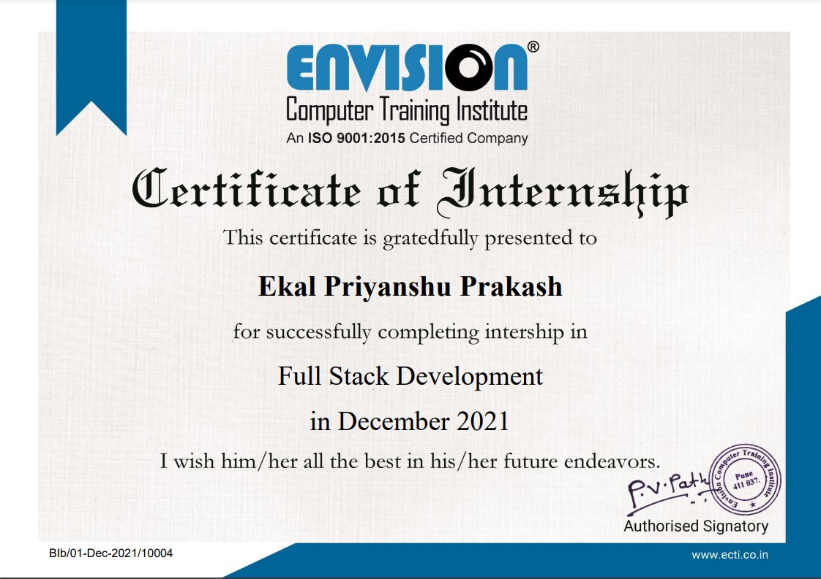

## Internship at **Envision Computer Training Institute, Pune**

About the company:

Established in the year 1999, Envision Computer Training Institute (ECTI) in Pune is a top player in the category Computer Training Institutes in the Pune. Created with vision to offer high quality training services to individuals and the corporates in the field of programming and engineering. It is known to provide certification courses top service in the following categories: ‘Web Designing Training’, ‘Android Training’, ‘Big Data’, and ‘Hadoop Training’ in Pune. It has created a proper IT training courses structure & duration to improve the effectiveness and efficiency of the courses that we offer.

Aim and Objectives:

1. To build a comprehensive approach towards knowledge acquisition in our students.
2. To instigate an application-oriented approach by providing exposure to latest trends in the industries.
3. Equip our students with pertinent know-how of market trends and build confidence to maintain their competitive edge.

Tools used:

* HTML
* CSS
* JavaScript
* Bootstrap
* jQuery

Working methodology

I was supposed to work on the Visual Studio Code, an open-source platform, for coding purpose. As VSCode is an open source web application and it also includes HTML, CSS and other add-ons, one can get easily suggestions so that he do not need to type the whole code statement. All my work has to be saved there.

They used to give me some problems as a classwork and some as homework. That was helpful to improve our skills and confidence. Also they took our practise test to check our progress.

They covered almost all the stuff about HTML, CSS, Bootstrap and JavaScript as well as important points about jQuery. At the end of the internship, they gave us a template as project with estimated duration of time. Also, They were friendly with us.

## About the Projects

We worked on Visual Studio Code to write the code & we used Google Chrome and Mozilla Firefox as platform to run the code. Our projects were based mostly on Bootstrap and JavaScript and we completed them using Bootstrap utilities and Bootstrap content delivery network (cdn). We took help of various classes of Bootstrap like navbar, carousel, row and column. Our project was based on a website of Civil Engineering Tools.

**Problem Statement:**

To create a website providing details about Civil engineering-based company and their tools.

**Solution:**

1. Prepare layout of the website to be made.
2. Add basic divisions like header, main, footer in the file.
3. Save the file with .html as the extension.
4. Add Bootstrap cdn for JavaScript and CSS.
5. Also add required cdns like icons from Font Awesome
6. Create navigation bar by referring Bootstrap documentation in the header division.
7. Add required links to the navbar using anchor tags. Also add a clean hover effect for the links.
8. Create a carousel section in main division.
9. Also add cards, accordion, badges, dropdowns, etc. as per requirement in the main division. Provide hover effects as per the requirements.
10. In the footer division, create divisions for contact, about in one column and address in another column. Also provide the copyright section in the footer.

**Output solution:**

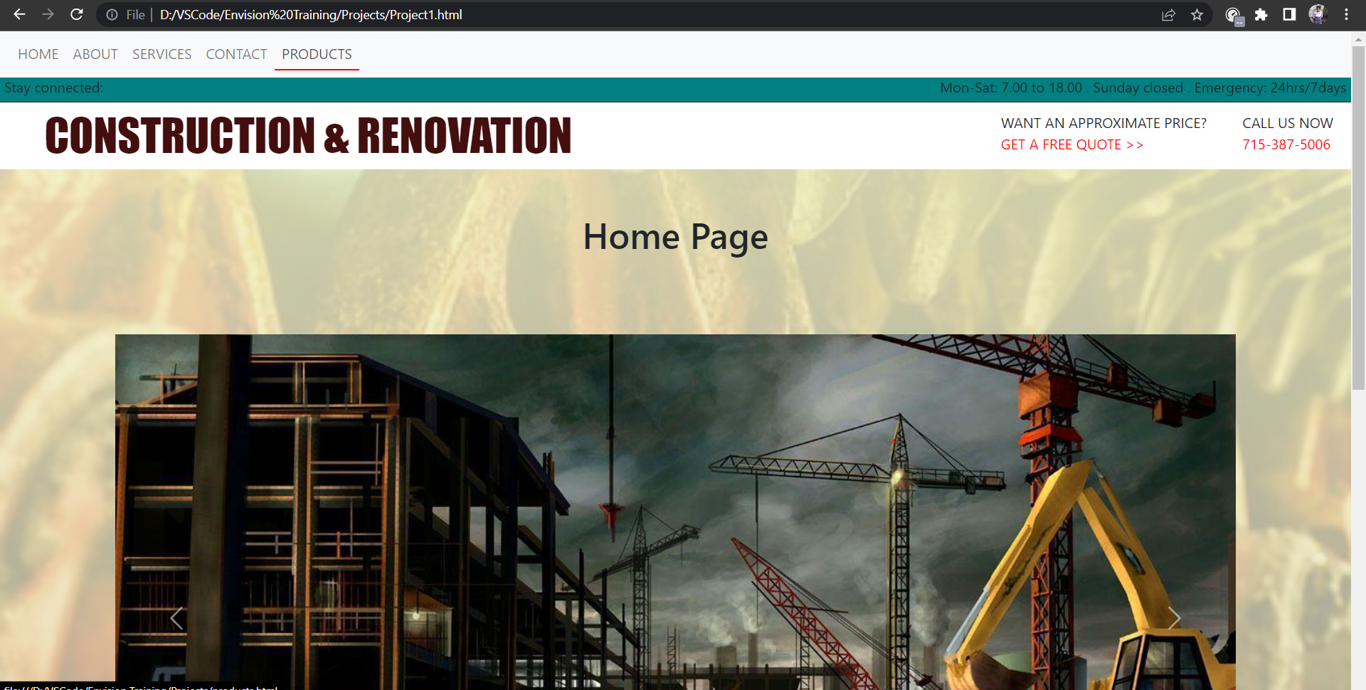

Home Page

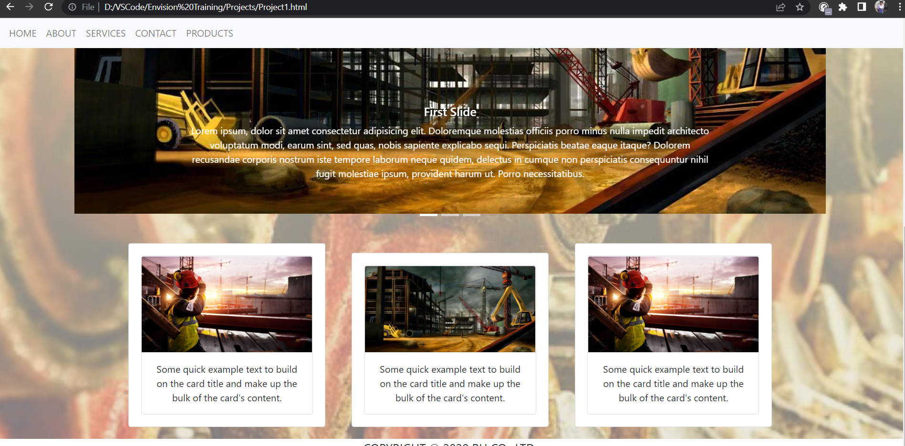

Home Page

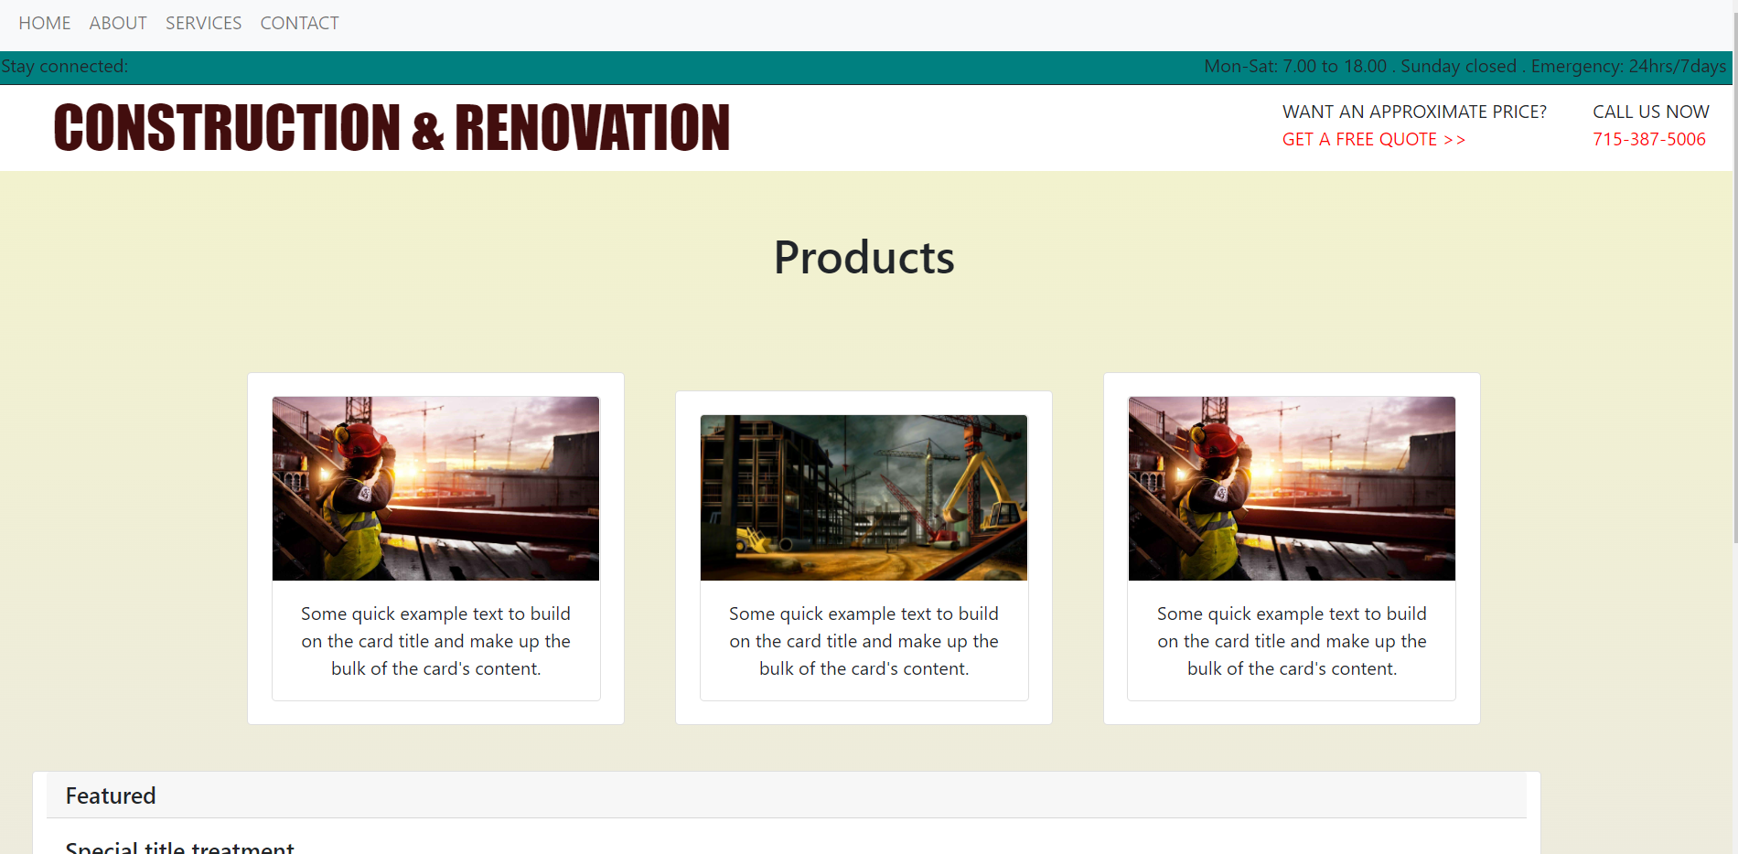

Products Page

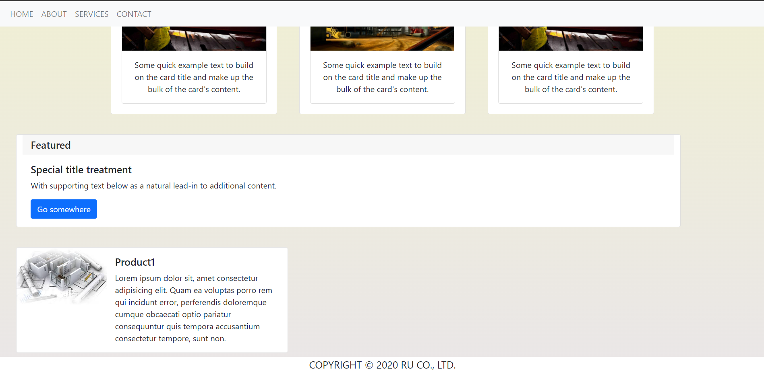

Products Page

**Template Snapshot**



Main div

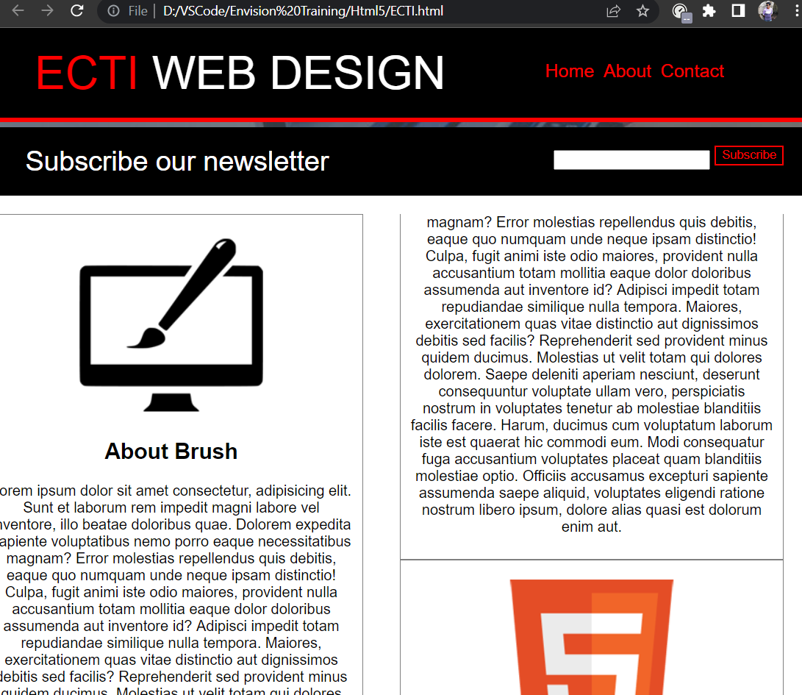

Layout

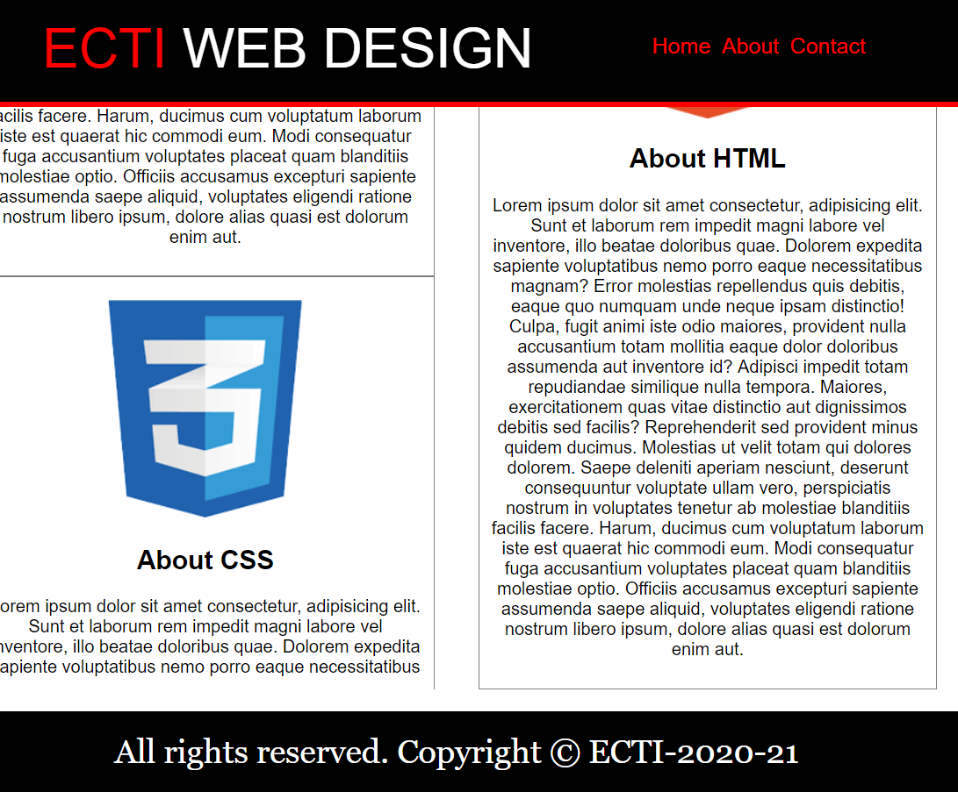

Footer menu

**JavaScript Snapshot**

Validation form

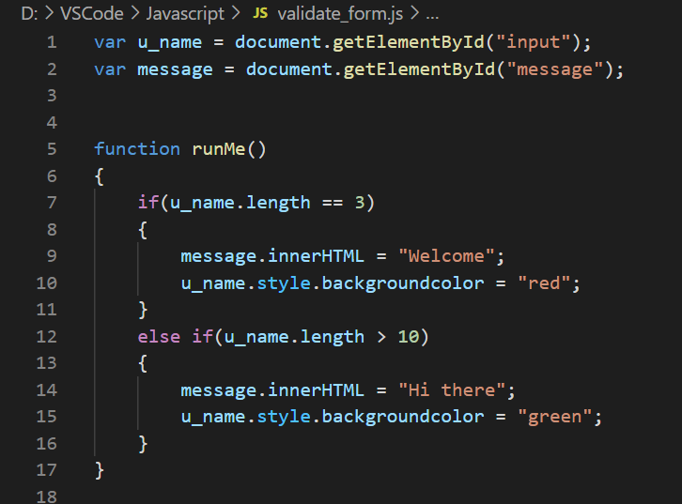

## Conclusion

Created a website providing details about Civil engineering-based company and their tools using HTML, CSS, JavaScript and Bootstrap.

## About my role

I did my work with sincerity. I learned the new technologies that the trainers of Envision Computer Training Institute have taught me. To solve their given tasks and complete the given projects, I used my knowledge efficiently.